CA™ Portal r12 Beta
CA™ Portal is an advanced solution streamlining the personalized delivery of complex information to your business and IT users in the context of their business processes. It is designed to be easy to implement and optimize the distribution of information assets across your enterprise. Leveraging common industry standards for reliability and extensibility, CA Portal is designed to facilitate integration and aggregation of information into a personalized, intelligent, and engaging Web-based environment enabling collaboration, business insight and effective decision-making.

Top Three Key Features
- Open, Configurable and Customizable Deployment Based on Open Standards
- Effective Content Delivery for Business Activity Monitoring (BAM) and Business Process Management (BPM)
- Externalized Identity and Access Management

How Do You Monitor Business Activity and Processes?
Your Business Users and IT staff are faced with increasing pressures and challenges to perform effectively in today’s fast-paced environments, requiring that information be more seamlessly integrated with business processes than ever before. At the same time, as your IT environment becomes more complex, software solutions must not only provide required functionality, they must also support open standards and provide extensible architectures that enable a smooth fit within your IT infrastructure.
Simultaneously, your employees, vendors, partners and customers expect access to the right information when and where they need it, in the appropriate form to enable faster and better decisions. A visual status of critical business processes and on-demand viewing of current business metrics and key performance indicators isn’t enough Timely alarms and alerts are required to connect business process understanding with action toward business process optimization, before crises arise.
Finally, regulatory requirements such as Sarbanes-Oxley and BASEL II, under which certain processes must be documented and IT controls verified, accentuate the need for dashboard display of business process status for compliance with key regulations.
In response to these pressures and challenges, your IT organization must deliver effective business services that support your enterprise goals and strategies. You must align business processes with your IT services, and ensure that these services are delivered in the most cost-effective and efficient manner.

Optimize Business
and IT
CA Portal enables high-value analysis and decision-making capabilities across your enterprise information assets and business processes. Providing insight into your business activities and business processes, CA Portal and its related dashboard solutions aggregate both structured and unstructured data assets, so you can leverage information and applications toward optimizing the processes that support your business. Integration of data, applications and business processes delivers rapid time-to-value by providing you with knowledge that is complete, relevant and personalized. Using J2EE and other open standards enables modular yet integrated solutions for incremental and expandable deployment.
CA Portal provides the following unique benefits:
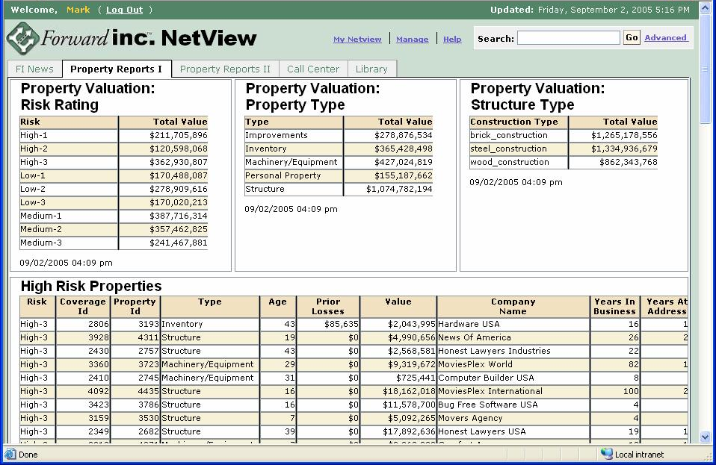
Open, Configurable and Customizable Deployment. CA Portal is designed for both deployment out-of-the-box and as a basis for more advanced configurations and deployments where you can build solutions using CA technology as a common services foundation for Web-delivered information and applications.
Cost-Effective Content Delivery.
CA Portal enables dashboard solutions
designed to help you monitor your business activities and provide the visualization environment for business process optimization. It complements Business Process Management (BPM) initiatives by providing important aggregation, visualization and refinement technologies that work with CleverPath Aion solutions.
Interoperability and Versatility. CA Portal components leverage key J2EE, Web services and other common standards – including JSR 168, WSRP and JSR 170 – in order to provide versatility, compatibility with intricate enterprise IT environments and integration with complementary technologies and solutions. The extended architecture and use of open standards increases flexibility, availability, reliability, stability, scalability and manageability of your portal-based applications.
Figure 1. The advanced, easy-to-learn UIs and comprehensive page management capabilities of CA Portal enable business process dashboards that are intuitive, flexible and extensible.
Effective and Efficient User Management CA Portal reduces the duplication of user and group administration by leveraging CA’s eTrust technology to implement an externalized user management model. Using the eTrust Embedded Identity and Access Management component enables CA Portal to integrate with the included default user management system or with your existing LDAP-compliant systems such as CA’s eTrust Admin or Microsoft Active Directory. The benefit to this integration is direct authentication of users via the enterprise directory while enabling single sign-on to applications that share your corporate authentication resource.

Distinctive Features and Functionalities
Intuitive, Flexible and Extensible. CA Portal is designed and architected to satisfy the requirements of your organization and for use as embedded technology within CA’s management software solutions and third-party partner products. The CA Portal component-oriented architecture provides you with both a rapid out-of-the-box experience and an environment where your Web-based business and IT management information and applications can be readily constructed and deployed.
- Easy-to-learn UIs Based on User-Centered Design Best Practices. CA Portal is based on a user centric

design (UCD) methodology that recognizes multiple user roles and associated use-case requirements for information interaction. The user interface (UI) leverages CA’s UI standards and industry practices and technologies resulting in a UI that is intuitive for both your business and IT users (see figure 1).

- Advanced Page Management. The concept of a portal page is well accepted as an information delivery mechanism because it aggregates both applications and structured and unstructured content. Portal applications are combinations of pages and portlets that range from shared distributed portal pages to completely personalized pages. Shared pages – created by a page producer and pushed to your targeted consumers – facilitate efficient aggregation and distribution of content to your groups and individual users. Pages can also be personalized and portlets configured by your end consumers, providing them with content appropriate to their individual role-based needs while filtering out irrelevant information. CA Portal provides page creation, layout, management and navigation capabilities that match the expanding requirements of your organization for effective information delivery to optimize business processes.

Business Optimization Through Business Activity Monitoring (BAM) and Business Process Management (BPM). Understanding and optimizing your business is a key focus of CA Portal. BAM enables organizations to effectively monitor business processes and engage in BPM and automation. BPM encompasses the management of explicit business processes from beginning to end – for example, insurance claims processing from the time a claim is made to when the payment is completed.
- Integrated Report Server and Builder. A robust reporting capability is included as a key integrated component of CA Portal, so you can build interactive dashboard visualizations that include tables and charts and deploy them in portlets. The graphical report designer provides a palette interface for the layout of display objects. Report and dashboard content rendering supports a variety of output formats, including Adobe PDF, and offers Web deployment, including prompting, filtering, and linking and drilling between and into content objects.
- Advanced Search and Crawling. CA Portal leverages advancements in search engine technology including sophisticated indexing, categorization, spidering and crawling, metadata search, query specification and full text search. For example, you can refine your targeted content and web links by using filters that are applied when crawling Web sites or file shares.
Extended Architecture. The CA Portal r12 architecture implements a portal framework that delivers functionality and services necessary for such a key component in your IT infrastructure. This architecture operates within a multi-tiered environment supporting presentation, business, and data integration layers. Leveraging advanced open standards, CA Portal delivers enhanced messaging, interoperability, user management, security and other services. With a long history of openness and support for standards, CA Portal is deployable on a wide array of hardware and software platform combinations including Windows, Linux and Unix operating systems, open-source and other application servers, multiple browsers and leading database management systems.
- Java, J2EE APIs, EJBs, JAAS. Within its multi-tiered architecture, CA

Portal uses J2EE APIs for standard interfaces such as the Java Authentication and Authorization Service (JAAS) for user management and security, and Enterprise JavaBeans (EJBs) for business logic and management services.
- JSR 168 and WSRP. Portlets are at the heart of any portal and provide the presentation layer for the business processes they represent. Aggregating portlets into pages enables you to integrate appropriate information and application content for effective business operations. CA Portal implements two new portlet standards which offer the potential to vastly increase the power and flexibility of your portlets.
The Java Community Process JSR 168 (JSR 168) portlet specification defines methods for creating and deploying portlets that embed control over their own configuration and operations. This standard supports interoperability and effectively enables portability of portlets from one JSR 168-compliant portal to another.
The OASIS Web Services for Remote Portlets (WSRP) Specification describes a Web services API for producing Web services-based portlets and consuming these portlets even when they are executing on a remote server. WSRP support includes both the ability for you to expose portlets as a WSRP producer and the ability to consume WSRP portlets hosted on other servers.
User Management and Security. CA Portal reduces duplication of user management and security tasks by providing a common interface to your existing corporate user management systems. By using CA Portal and taking advantage of the experience and market leadership of CA eTrust security technologies, you can focus on delivering role-based, group-based and user-based business information while leveraging your corporate user management system. In addition, Java Authentication and Authorization Service (JAAS) and other industry standards offer interoperability and extensibility.
- eTrust Embedded Identity and Access Management (eIAM). eTrust Identity and Access Management provides an embedded user management system and integration with LDAP-compliant systems such as CA’s eTrust™ Admin, Microsoft Active Directory and others.
- Policy-Based Permission Model. A policy-based permission model supports greater flexibility by allowing you to define access permissions on a wider basis, while supporting more granular permissions when needed.
- Dynamic Groups. In addition to supporting global groups defined in the enterprise directory, CA Portal supports the addition of dynamic groups for more community-oriented user organization and information delivery.
Content Management Flexibility. Increasingly, your business users need to manage, review and approve documents before they are published to internal and external consumers. CA Portal includes portal-oriented content management and approval workflow services, focused on documents and other content that is bound for delivery in portlets and portal pages.
- Content Library. CA Portal is built around a single content repository supporting all major document types. This repository enables library services including document uploads and downloads, check-in and check-out, history and versioning, search, extracted and user-defined properties, subscription and notification, content approval workflows and setting of permissions for governing content usage on your portal pages.
- JSR 170 and WebDAV. CA Portal implements another standard, Java Community Process JSR 170: Content Repository for JavaTM technology (JSR 170). JSR 170 provides API specifications for a common set of interfaces to access content repositories. This standards-based interface is designed to provide openness and flexibility for programmatic access to the CA Portal Library. CA Portal delivers an API based on JSR 170 while preserving a standard WebDAV interface for access to library content.
Workflow. CA Portal includes the powerful CA workflow engine supporting approval processes for content management and portal page distribution to your groups and users. The workflow engine enables these business processes to be defined using a highly intuitive graphical environment and provides automation of business processes during which documents, information or tasks are passed between your users in a pre-defined flow. User interaction with the workflow engine is via browser-based forms deployable in CA Portal.
Supported Environments
(See CA Portal r12 Beta Readme file for complete system requirement details)
Server components
- Microsoft Windows 2003 Server
- Sun Solaris (Sparc) 9.0, 10.0
- Red Hat Enterprise Linux 3.0, 4.0 (Intel)
- HP-UX 11i PA-RISC
- HP-UX 11.23 Itanium

- IBM AIX 5.2, 5.3
- SUSE Linux Enterprise Server for Intel 8.0, 9.0
Client components (CA Workflow, CA Report Builder)
- Microsoft Windows XP, 2003
Browsers
- Microsoft Internet Explorer 6.0
- Mozilla 1.7
- FireFox 1.0

For more information, call 1-888-746-4737 or visit ca.com

